C++ assignment

# Name: Syed Muhammad Hassaan

# Sec-A

# Roll number: 460991

Part 1:

1. #include <iostream>
2. using namespace std;

5. int main (){
6. int x;
7. cout<< "Please Enter the Province from the Given Options 1-4: "<<endl;
8. cout<<"1 - Punjab"<<endl;
9. cout<<"2 - Baluchistan"<<endl;
10. cout<<"3 - KPK"<<endl;
11. cout<<"4 - Sindh"<<endl;
12. cin>> x;
13. switch(x){
14. case 1:
15. cout<<"The Population for Punjab is 110 million";
16. break;
17. case 2:
18. cout<<"The Population for Baluchistan is 21.7 million";
19. break;
20. case 3:
21. cout<<"The Population for KPK is 40.8 million";
22. break;
23. case 4:
24. cout<<"The Population for Sindh is 47.9 million";
25. break;
26. default:
27. cout<<"Entered input is Invalid";
28. }
29. return 0;
30. }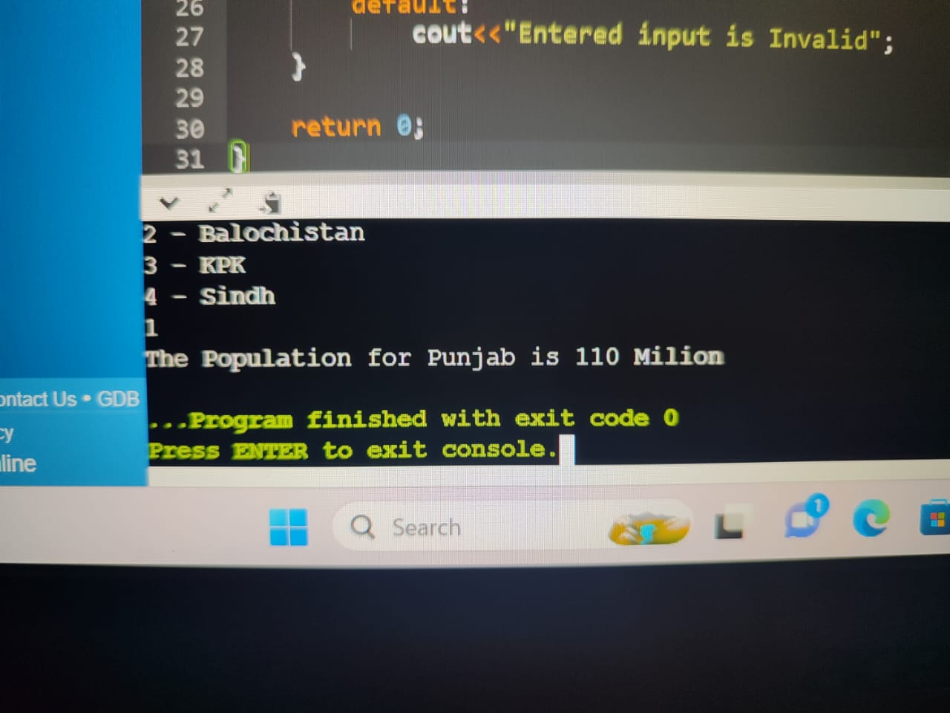

Part-2:

1. #include <iostream>
2. Using namespace std;
3. //int main(){
4. // char alphab;
5. ////asking the user to enter alphabet
6. // cout<<"please enter the alphabet you want to check"<<endl;
7. // cin>>alphab;
8. ////using switch statement to check if it is a vowel or consonant and outputting desired results
9. // switch (alphab){
10. // case 'a': cout<<"it is vowel"<<endl;
11. // break;
12. // case 'e': cout<<"it is vowel"<<endl;
13. // break;
14. // case 'i': cout<<"it is vowel"<<endl;
15. // break;
16. // case 'o': cout<<"it is vowel"<<endl;
17. // break;
18. // case 'u': cout<<"it is vowel"<<endl;
19. // break;
20. // default:cout<<"it is consonant"<<endl;
21. // }
22. // return 0;
23. //
24. //}
25. 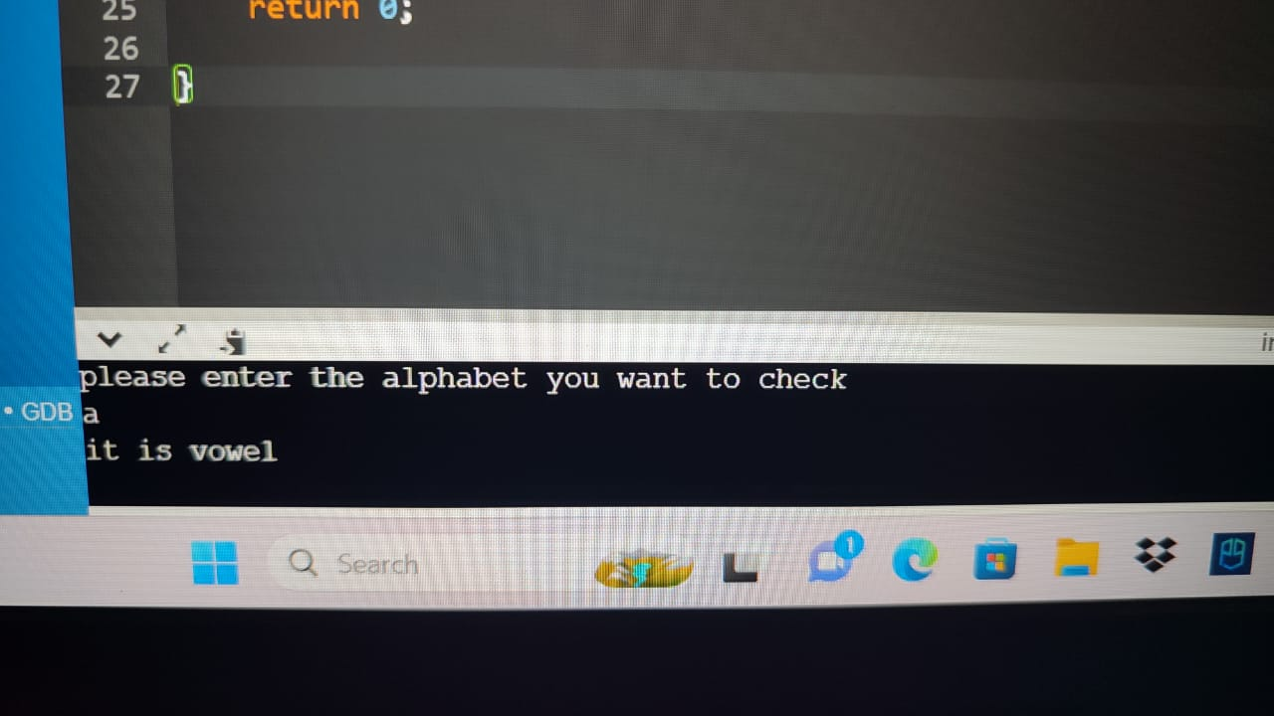

Part-3

1. #include<iostream>
2. using namespace std;
4. int main(){
5. int age;
6. cout<<"Please Enter your Age: ";
7. cin>>age;
8. if(age<13) {
9. cout<<"You are a Child!";
10. }
11. else{
12. if(age>=13 && age<=19) {
13. cout<<"You are a Teenager!";
14. }
15. else{
16. cout<<"You are an Adult!";
17. }
18. }
20. return 0;
21. }

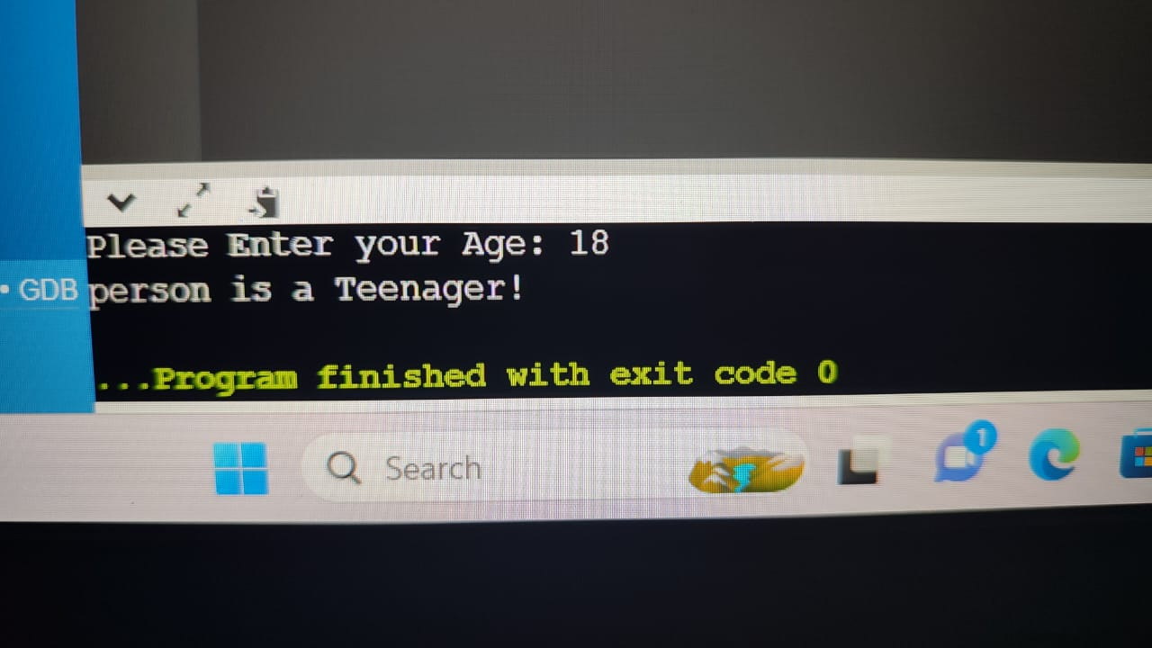

Part-4

1. #include <iostream>
2. using namespace std;

5. int main () {
6. int a,b,c;
7. cout<<"Please Input Number A: ";
8. cin>>a;
9. cout<<"Please Input Number B: ";
10. cin>>b;
11. cout<<"Please Input Number C: ";
12. cin>>c;
13. if(a>b){
14. if(a>c){
15. cout<<"A is Greatest!";
16. }
17. else{
18. cout<<"C is Greatest!";
19. }
20. }
21. else if(b>a){
22. if(b>c){
23. cout<<"B is Greatest!";
24. }
25. else{
26. cout<<"C is Greatest!";
27. }
28. }
29. return 0;
30. }
31. 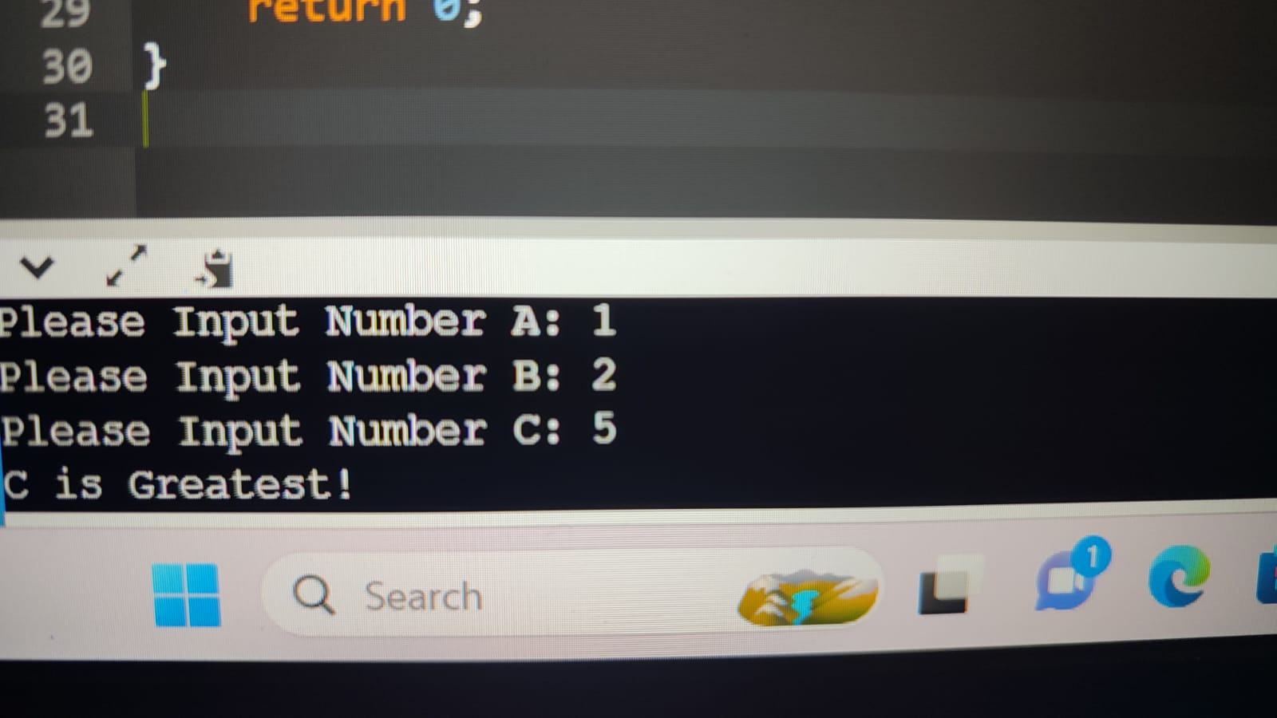

Part-5:

1. #include <iostream>
2. Using namespace std;
3. int main(){
4. char lett;
5. //ask the user to enter the alphabet
6. cout<<"please enter alphabet you want to check"<<endl;
7. cin>>lett;
8. //using nested if to check alphabet against all the vowels and outputting the desired results
9. if (lett=='a'){
10. cout<<"it is vowel"<<endl;
11. }
12. else{ if (lett=='e'){cout<<"it is vowel"<<endl;
13. }
14. else if (lett=='i'){cout<<"it is vowel"<<endl;
15. }
16. else if (lett=='o'){cout<<"it is vowel"<<endl;
17. }
18. else if (lett=='u'){cout<<"it is vowel"<<endl;
19. }
20. else {cout<<"it is the consonant"<<endl;
21. }
22. }
23. return 0;
24. }
25. 